ECE 461/561 –   
Embedded System Design  
Project 3: Energy Optimization

# Overview

In this project you will develop code to implement a stopwatch, and then analyze and optimize its energy performance.

You will use a supercapacitor to determine energy use. Measuring its voltage before (V1) and after (V2) enables the calculation of the energy before and after. The difference in energy *W* is the amount used by the circuit:

A constant current load *I* will take *t* seconds to discharge the capacitor from V1 to V2:

A constant resistance load R will take *t* seconds to discharge the capacitor from V1 to V2:

We can extend the life of the circuit by connecting the supercapacitor to the 5.0 V supply rail, rather than the 3.3 V supply rail at location C73.

Remember that reducing the compute cycles needed for a program will also reducing the energy required. So as in the previous project, profile the code to find the slow parts, and then optimize them as much as you can. Feel free to optimize ***any*** code in the system which will help your demonstration program run faster. 10% of your grade will be based on your final program’s energy efficiency.

# Stopwatch Program

Requirements:

* Display elapsed time on the LCD: Hours, minutes, seconds, tenths of seconds. HH:MM:SS.S
* Update the display every 100 ms
* Respond to switches within 100 ms (with polling or interrupts)
* Switch 1 starts or resumes the timer counting
* Switch 2 stops the timer counting
* Switch 3 resets timer value to 0.

Deliverables:

* Project directory, including source code and subdirectories
* Report with documentation, and stepwise performance analysis and description of optimizations (with their quantitative impact).

Suggestions:

* Turn off each unused MCU peripheral by clearing its clock enable bit in the PER0 register
* Turn off unused peripherals on RDK
* Disconnect unswitchable LEDs
* Turn off the LCD backlight
* Speed up SPI communications
* Adjust LCD settings (contrast, boost voltage, etc.) to maximize LCD visibility at low voltages
* Use MCU stop or halt modes
* Adjust the low-voltage detector in the MCU to allow low-voltage operation

Resources:

* RL78/G13 User’s Manual: Hardware
  + Ch. 18 – Standby Function
  + Ch. 21 – Voltage Detector
  + Ch. 24 – Option Byte
* Textbook
  + Ch. 13 – Power and Energy Optimization
  + Ch. 12 – Optimizing for Program Speed
  + Ch. 10 – Peripherals for Robustness and Performance
  + Ch. 8 – Serial Communications
* Supercapacitor Information
  + Technical Information: <http://industrial.panasonic.com/www-ctlg/tech/tABC0000_WW.html>
  + 0.33 F supercapacitor - Digikey P11064-ND.

<http://industrial.panasonic.com/www-cgi/jvcr13pz.cgi?E+PZ+3+ABC0001+EECS0HD334H+7+WW>

* + 0.022 F supercapacitor – Digikey P10785-ND.    
    <http://industrial.panasonic.com/www-cgi/jvcr13pz.cgi?E+PZ+3+ABC0001+EECS0HD223H+7+WW>
* LCD controller data sheet
  + <http://www.tianma-usa.com/web/uploads/controller/20080316012510_ST7579_V0.9a.pdf>

# RDK Modifications

## Add jumper to disable debug MCU

A second MCU () is hidden under the LCD. It continues running even when not needed, drawing about 17 mA. To reduce this current, we will add a jumper to assert its reset signal by pulling it to ground. Insert a bent wire between pins 1 and 2 of J15. Be sure to remove this jumper when you need to use the debugger!

## Add Supercapacitor

The supercapacitor can be mounted on header in the prototyping area, where it has access to the 5 V power supply. See the Appendix for full size figures.

**Required:**  
1. RL78 Development Kit  
2. SuperCap – provided in the class  
3. Male Headers – provided in the class  
4. Female Headers – provided in the class  
5. A short piece of wire (about 35 mm)  
6. Soldering equipment

#### Process:

**Step 1:** Solder the Male headers on the general purpose part of the RL78 development kit such that one of the pins is on the 5V0 as shown in figure.

**Step 2:** Solder a piece of wire from ground (GND) to the other pin of the header.

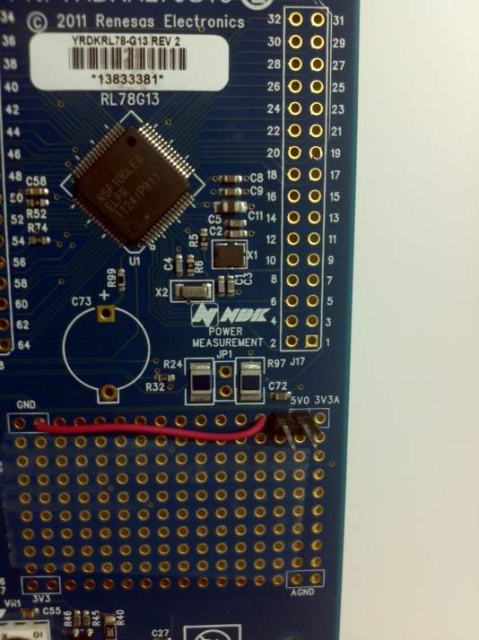

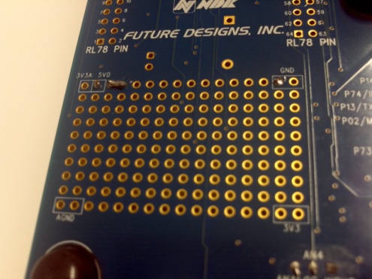

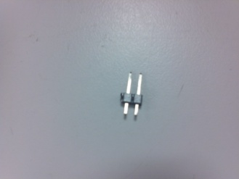

Figure1: Male Header

Figure 3: Soldered Board - Bottom Side

Figure 2: Male Header on Board – Top Side

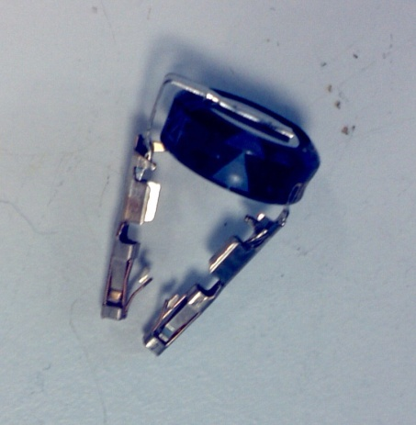**Step 3:** Solder the female headers on the pins of the SuperCap as shown in figure,

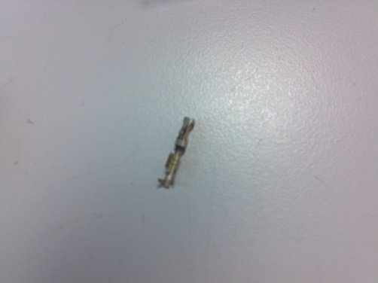

Figure 4: Female Header

Figure 5: SuperCap with Female Header

**Step 4:** Connect the capacitor to the board by plugging it in the header.

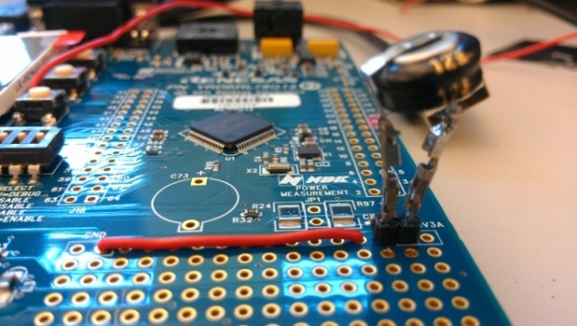

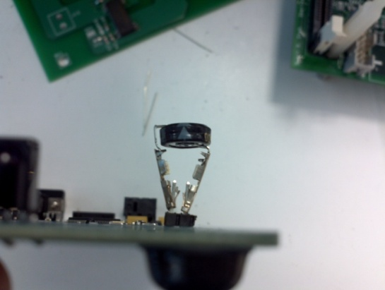

Figure 6: SuperCap On RL78 Board

Figure7: SuperCap on RL78 Board

**NOTE:**

**Before connecting the capacitor on the board, make sure that you have the negative terminal of the capacitor (TOP one) being connected to GND and the positive (BOTTOM one) being connected to 5V0 pins of the header.**

# Demonstration Requirements

You must demonstrate your program to the instructor or a TA. This will involve charging the supercapacitor and then timing how long the system runs before it stops operating.

# Submission Requirements

Submit the following items in a zip archive through Wolfware.

1. Project workspace, source and object files.
2. Project Report (PDF)
   1. Introduction
   2. Energy Use Analysis and Optimization
      1. Initial average power use, with analysis of different components.
      2. Narrative description of each optimization you tried, with measurements of performance before and after.
      3. Final average power use.
      4. Analysis and discussion of results
   3. Lessons learned in this project, and how you might do things differently next time
      1. Technical issues (processor, peripherals, compiler, assembly code, etc.)
      2. Your own software development process
   4. Conclusions

# Grading

Your grade will be based upon the submitted report and the energy efficiency of your fully optimized program.

# Appendix: Figures

**Figure 1: Male Header**

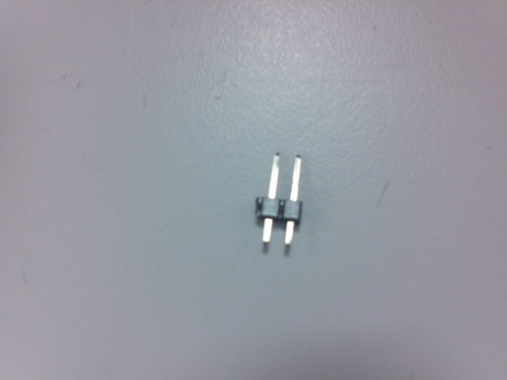

**Figure 2: Male Header on Board – Top Side**

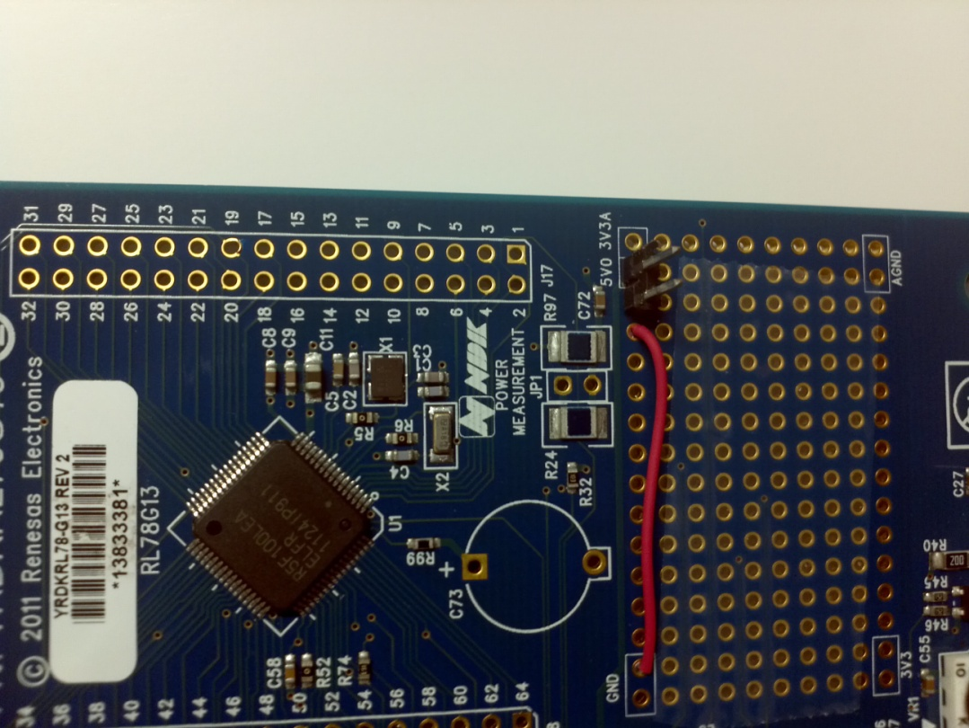

**Figure 3: Soldered Board – Bottom Side**

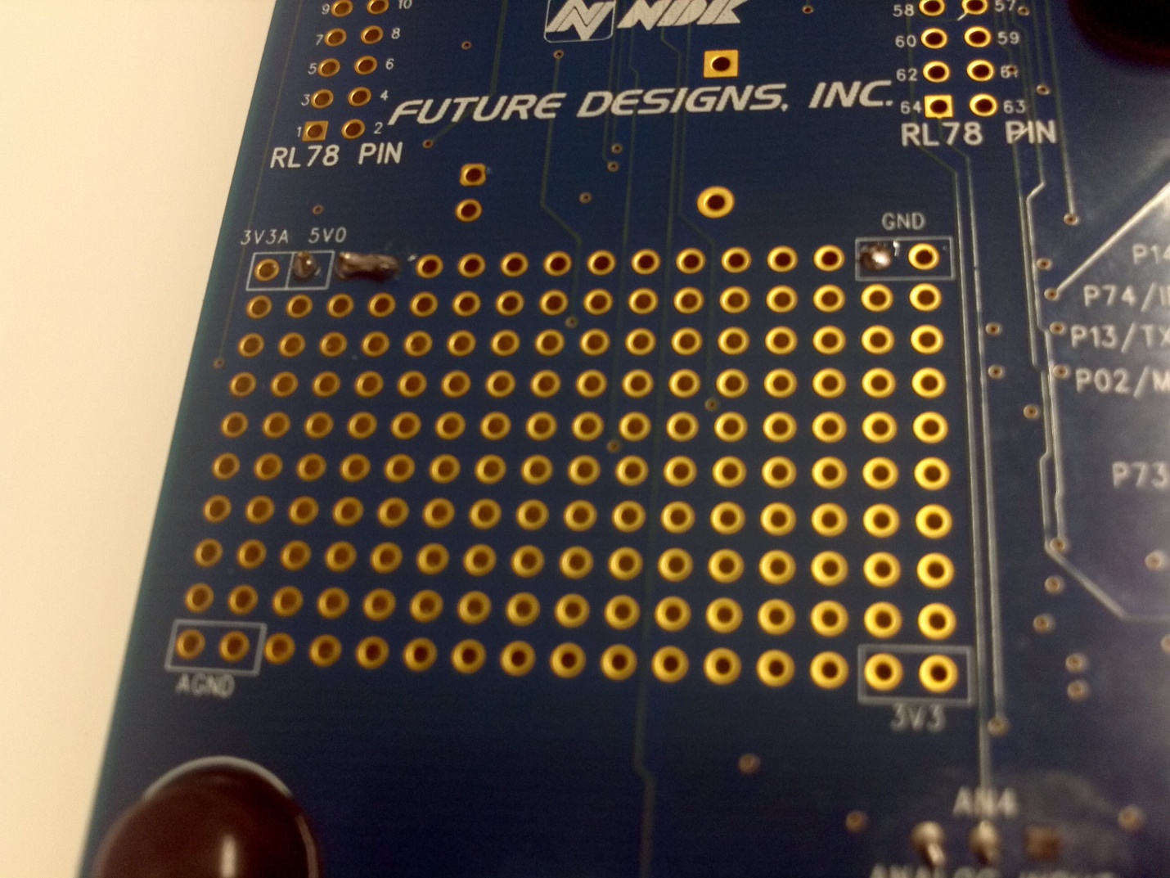

**Figure 4: Female Header**

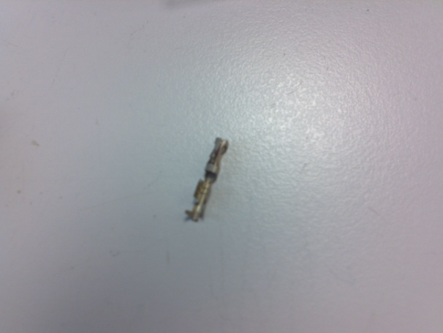

**Figure 5: SuperCap with Female Header**

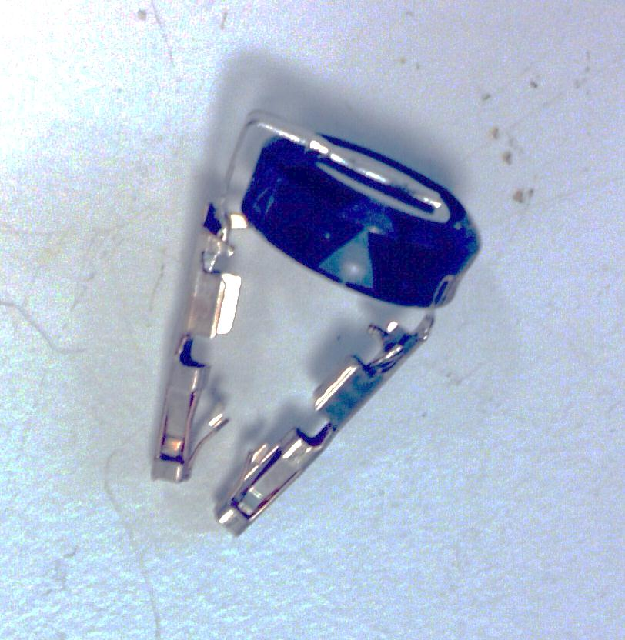

**Figure 6: SuperCap on RL78 Board**

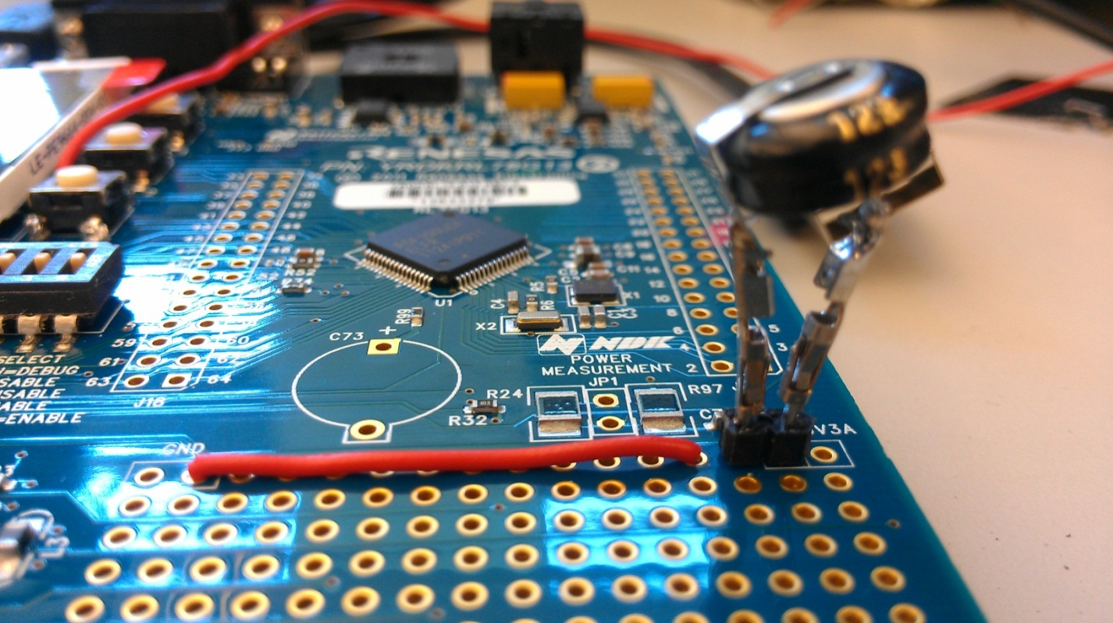

**Figure 7: SuperCap on RL78 Board**

